 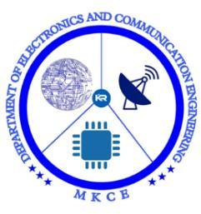 

**WEBPAGE DEVELOPMENT ON HALL BOOKING SYSTEM**

## A MINOR PROJECT- II REPORT

**Submitted By**

|  |  |
| --- | --- |
| JANAPRIYA R | (927621BEC067) |
|  |  |
|  |  |

# BACHELOR OF ENGINEERING

in

# DEPARTMENTOF ELECTRONICS AND COMMUNICATION ENGINEERING

**M.KUMARASAMY COLLEGE OF ENGINEERING**

(Autonomous)

# KARUR – 639 113

**APRIL 2023**

**M.KUMARASAMY COLLEGE OF ENGINEERING, KARUR**

# BONAFIDE CERTIFICATE

Certified that this **18ECP104L - Minor Project II** report **"WEBPAGE DEVELOPMENT ON HALL BOOKING SYSTEM"** is the Bonafide work of **"JANANI K(927621BEC066), JANAPRIYA R(927621BEC067), JAYARISHA V(927621BEC068), KARNIKASHREE C(927621BEC071)"**

who carried out the project work under my supervision in the academic year

## 2022-2023-EVEN.

|  |  |
| --- | --- |
| **SIGNATURE** | **SIGNATURE** |
| **Dr. S PALANIVEL RAJAN M.E., Ph.D., D.Litt(USA).,**  **HEAD OF THE DEPARTMENT,**  **Professor,**  Department of Electronics and Communication Engineering,  M. Kumarasamy College of Engineering,  Thalavapalayam, Karur-639113. | **Dr. S PALANIVEL RAJAN M.E., Ph.D., D.Litt(USA).,**  **SUPERVISOR, Professor,** Department of Electronics and Communication Engineering,  M. Kumarasamy College of  Engineering,Thalavapalayam, Karur- 639113**.** |

This project report has been submitted for the **18ECP104L- Minor Project II** Viva Voce Examination held at M.Kumarasamy College of Engineering, Karur on

.

**PROJECT COORDINATOR**

# INSTITUTION VISION AND MISSION

## Vision

To emerge as a leader among the top institutions in the field of technical education.

## Mission

**M1:** Produces smart technocrats with empirical knowledge who can surmount the global challenges

**M2:** Create a divers, fully engaged, learner-centric campus environment to provide quality education to the students

**M3:** Maintain mutually beneficial partnerships with our alumni, industry, and Professional associations

# DEPARTMENT VISION, MISSION, PEO, PO AND PSO

## Vision

To empower the Electronics and Communication Engineering students with emerging technologies, professionalism, innovative research and social responsibility.

## Mission

**M1:** Attain the academic excellence through innovative teaching learning process, research areas & laboratories and Consultancy projects.

**M2:** Inculcate the students in problem solving and lifelong learning ability.

**M3:** Provide entrepreneurial skills and leadership qualities.

**M4:** Render the technical knowledge and skills of faculty members.

## Program Educational Objectives

**PEO1: Core Competence:** Graduates will have a successful career in academia or industry associated with Electronics and Communication Engineering.

**PEO2: Professionalism:** Graduates will provide feasible solutions for the challenging problems through comprehensive research and innovation in the allied areas of Electronics and Communication Engineering.

**PEO3: Lifelong Learning:** Graduates will contribute to the social needs through lifelong learning, practicing professional ethics and leadership quality

## Program Outcomes

**PO 1: Engineering knowledge:** Apply the knowledge of mathematics, science, engineering fundamentals, and an engineering specialization to the solution of complex engineering problems.

**PO 2: Problem analysis:** Identify, formulate, review research literature, and analyze complex engineering problems reaching substantiated conclusions using first principles of mathematics, natural sciences, and engineering sciences.

**PO 3: Design/development of solutions:** Design solutions for complex engineering problems and design system components or processes that meet the specified needs with appropriate consideration for the public health and safety, and the cultural, societal, and environmental considerations.

**PO 4: Conduct investigations of complex problems:** Use research-based knowledge and research methods including design of experiments, analysis and interpretation of data, and synthesis of the information to provide valid conclusions.

**PO 5: Modern tool usage:** Create, select, and apply appropriate techniques, resources, and modern engineering and IT tools including prediction and modeling to complex engineering activities with an understanding of the limitations.

**PO 6: The engineer and society:** Apply reasoning informed by the contextual knowledge to assess societal, health, safety, legal and cultural issues and the consequent responsibilities relevant to the professional engineering practice.

**PO 7: Environment and sustainability:** Understand the impact of the professional engineering solutions in societal and environmental contexts, and demonstrate the knowledge of, and need for sustainable development.

**PO 8: Ethics:** Apply ethical principles and commit to professional ethics and responsibilities and norms of the engineering practice.

**PO 9: Individual and team work:** Function effectively as an individual, and as a member or leader in diverse teams, and in multidisciplinary settings.

**PO 10: Communication:** Communicate effectively on complex engineering activities with the engineering community and with society at large, such as, being able to comprehend and write effective reports and design documentation, make effective presentations, and give and receive clear instructions.

**PO 11: Project management and finance:** Demonstrate knowledge and understanding of the engineering and management principles and apply these to one’s own work, as a member and leader in a team, to manage projects and in multidisciplinary environments.

**PO 12: Life-long learning:** Recognize the need for, and have the preparation and ability to engage in independent and life-long learning in the broadest context of technological change.

## Program Specific Outcomes

**PSO1:** Applying knowledge in various areas, like Electronics, Communications, Signal processing, VLSI, Embedded systems etc., in the design and implementation of Engineering application.

**PSO2:** Able to solve complex problems in Electronics and Communication Engineering with analytical and managerial skills either independently or in team using latest hardware and software tools to fulfil the industrial expectations.

|  |  |
| --- | --- |
| **Abstract** | **Matching with POs, PSOs** |
| Hall Booking System, web- based application, developing an online hall booking system | PO1, PO2, PO3, PO4, PO5, PO6, PO7, PO8, PO9, PO10, PO11, PO12, PSO1, PSO2 |

.

# ACKNOWLEDGEMENT

Our sincere thanks to **Thiru.M.Kumarasamy, Chairman** and **Dr. K.Ramakrishnan, Secretary** of **M.Kumarasamy College of Engineering** for providing extraordinary infrastructure, which helped us to complete this project in time.

It is a great privilege for us to express our gratitude to **Dr.B.S.Murugan., B.Tech., M.Tech., Ph.D., Principal** for providing us right ambiance to carry out this project work.

We would like to thank **Dr.S.Palanivel Rajan, M.E., M.B.A., Ph.D., D.Litt (USA)., Professor and Head**, **Department of Electronics and Communication Engineering** for his unwavering moral support and constant encouragement towards the completion of this project work.

We offer our wholehearted thanks to our **Project Supervisor, Dr.S.Palanivel Rajan, M.E., M.B.A., Ph.D., D.Litt (USA)., Professor**, Department of Electronics and Communication Engineering for his precious guidance, tremendous supervision, kind cooperation, valuable suggestions and support rendered in making our project to be successful.

We would like to thank our **Minor Project Co-ordinator**, **Dr.E.Dinesh, M.E., Ph.D., Associate Professor**, Department of Electronics and Communication Engineering for his kind cooperation and culminating in the successful completion of this project work. We are glad to thank all the Faculty Members of the Department of Electronics and Communication Engineering for extending a warm helping hand and valuable suggestions throughout the project. Words are boundless to thank our Parents and Friends for their motivation to complete this project successfully.

# ABSTRACT

The Hall Booking System is a web-based application project. It includes all the features and functions needed to efficiently manage the halls in an institution. It includes an administrator account which is used to handle all the system functionality. The system tracks the status and booking details of the user. This project is aimed at developing an online hall booking system that is of importance to either an organization. The Hall booking System is a web-based application that can be accessed throughout the organization. This system can be used to book the halls of the institution and manage their approvals. Hall Booking application will reduce paper work and maintains record in more efficient way. This system provides user-friendly environment while booking the hall it gives suggestion regarding the selection of hall based on the availability. The concern head can view the list of request. In order to maintain the records of the bookings made by the users. As this is the online-era, where everything is online we need to develop a system in online which is very useful to maintain booking records by the administrator. The purpose of this project is to make the process of booking the halls in an institution online. With this, the institutes can access the booking records in a faster way and without any loss of data.

## TABLE OF CONTENTS

|  |  |  |  |  |
| --- | --- | --- | --- | --- |
| **CHAPTER**  **No.** |  |  | **CONTENTS** | **PAGE**  **No.** |
|  | **Institution Vision and Mission** | | | **iii** |
|  | **Department Vision and Mission** | | | **iii** |
|  | **Department PEOs, POs and PSOs** | | | **iv** |
|  | **Abstract** | |  | **viii** |
|  | **List of Figures** | | | **x** |
|  | **List of Abbreviations** | | | **xi** |
| **1** | **INTRODUCTION** | | | **1** |
| **2** | **LITERATURE SURVEY** | | | **3** |
|  | 2.1 | Existing System | | 3 |
|  | 2.2 | Proposed System | | 3 |
| **3** | **DESCRIPTION** | | | **5** |
|  | 3.1 | Introduction | | 5 |
|  | 3.2 | Block Diagram | | 7 |
|  | 3.3 | Working Principle | | 8 |
|  |  | 3.3.1 | HTML | 8 |
|  |  | 3.3.2 | PHP | 8 |
|  |  | 3.3.3 | MYSQL | 9 |
|  | 3.4 | Merits And Demerits | | 9 |
|  | 3.5 | Applications | | 10 |
| **4** | **RESULT** | |  | **12** |
| **5** | **CONCLUSION AND FUTURE SCOPE** | | | **13** |
|  | **APPENDICES** | | | **14** |
|  | 5.1 | SCREENSHOTS | | 14 |
|  | **REFERENCE** | | | 16 |

**LIST OF FIGURES**

|  |  |  |
| --- | --- | --- |
| **FIGURE No** | **TITLE** | **PAGE No.** |
| 3.1 | Block Diagram | 7 |
| 5.1.1 | Index Page | 14 |
| 5.1.2 | Hall Selection | 14 |
| 5.1.3 | Booking Details | 15 |
| 5.1.4 | Booking Confirmation | 15 |

**LIST OF ABBREVIATIONS**

|  |  |
| --- | --- |
| **ACRONYM** | **ABBREVIATIONS** |
| HTML | Hypertext Mark-up Language |
| PHP | Hypertext Pre-processor |
| MySQL | My Structured Query Language |

# INTRODUCTION

This project is aimed at developing a web based Hall Booking system which is of importance to either an organization or a college. The Hall Booking system is an Intranet based application that can be accessed throughout the organization or a specified group/Dept. This system can be used to automate the workflow of bookings and their approvals. The approval of the booking is manual. There are features like e-mail notifications, cancellation of leave, approval of leave, report generators etc in this Tool. This project is aimed at developing a web based Hall Booking Tool, which is of importance to either an organization or a college. The booking is an Intranet based application that can be accessed throughout the organization or a specified group/Dept. This system can be used to automate the workflow of booking applications and their approvals. The approval and cancelation are made manual. Functional components of the project: There are registered people in the system. Some are approvers. An approver can also be a requestor. In an organization, the hierarchy could be Engineers/Managers/Business Managers/Managing Director etc. In a college, it could be Supervisor. Following is a list of functionalities of the system.

* A person logging into the system as a user can view the list of halls to be booked.
* Selection of hall to be booked.
* Updating Date and Session.
* The user should update his/her details asked to be filled in the next page.
* After updating the details the user should confirm his/her booking.
* A person logging in as the admin can view the booking requests.
* The admin can check the availability and can approve or decline the request.
* As per the option chosen by the admin, the e-mail has been sent to the user who booked the hall.

Get help about the booking system on how to book the hall in the system. The system allows you to book hall in an organization. The hall booking system helps both the user and the admin. The system is easy to access and book halls organisation. Just by clicking on the buttons and updating the details who book the hall in the system. After booking, the admin will check the availability and send the confirmation though mail. The hall booking system makes the process quick as much as possible. The approval process are done by the admin. The admin also as their own login to approve the booking for the particular user the user is notified through email about the status of the booking The user can receive confirmation mail or cancellation mail from the admin.

# LITERATURE SURVEY

## EXISTING SYSTEM

In existing system the booking is done by manual process. In the existing system the user can book the hall by a phone call or book on their presence. After booking, the person should wait for their approval. If there is no hall available, the admin may forget to intimate the user on their on their request. Hence checking the availability of the halls the admin should accept the approve. So, the existing system is carries more time to do a piece of work for this reason. The online hall booking system is implemented. This is the major disadvantage of the existing system are given below;

* + - All Work are done Manually.
    - Cannot check availability.
    - No use of Web Services.
    - Maintaining booking records.
    - Less Security.
    - No proper coordination between different Applications and Users.
    - Fewer Users - Friendly.

## PROPOSED SYSTEM

The ‘Hall Booking System’ Approaches all about institutional practices and processes that are taken into consideration, the user and the admin can be benefitted. The Hall Booking System is a management information system for institution’s Hall Booking data. An Online Hall Booking System is a platform in which the user can book halls for their event.

The user can get their confirmation through the email.

* User friendliness is provided in the application with various controls.
* The system makes the overall project management much easier and flexible.
* Readily upload the latest updates, allows user to check the availability at anu instant.
* There is no risk of data mismanagement at any level while the project development is under process.

# DESCRIPTION

## INTRODUCTION

This project is aimed at developing a web based Hall Booking system which is of importance to either an organization or a college. The Hall Booking system is an Intranet based application that can be accessed throughout the organization or a specified group/Dept. This system can be used to automate the workflow of bookings and their approvals. The approval of the booking is manual. There are features like e-mail notifications, cancellation of leave, approval of leave, report generators etc in this Tool. This project is aimed at developing a web based Hall Booking Tool, which is of importance to either an organization or a college. The booking is an Intranet based application that can be accessed throughout the organization or a specified group/Dept. This system can be used to automate the workflow of booking applications and their approvals. The approval and cancelation are made manual. Functional components of the project. There are registered people in the system. Some are approvers. An approver can also be a requestor. In an organization, the hierarchy could be Engineers/Managers/Business Managers/Managing Director etc. In a college, it could be Supervisor. Following is a list of functionalities of the system.

* + - A person logging into the system as a user can view the list of halls to be booked.
    - Selection of hall to be booked.
    - Updating Date and Session.
    - The user should update his/her details asked to be filled in the next page.
    - After updating the details the user should confirm his/her booking.
    - A person logging in as the admin can view the booking requests.
    - The admin can check the availability and can approve or decline the request.

As per the option chosen by the admin, the e-mail has been sent to the user who booked the hall. Get help about the booking system on how to book the hall in the system. The system allows you to book hall in an organization. The hall booking system helps both the user and the admin. The system is easy to access and book halls organisation. Just by clicking on the buttons and updating the details who book the hall in the system. After booking, the admin will check the availability and send the confirmation though mail. The user can receive confirmation mail or cancellation mail from the admin.

In today’s world, the technology has been growing. Everything has become online and ¾ of the people where using the technology. Everything and everyone have upgraded to their level of knowledge. This hall booking system helps the user to save their time and get benefited. The Online Hall booking system works efficiently on both user and admin domain.

## BLOCK DIAGRAM:

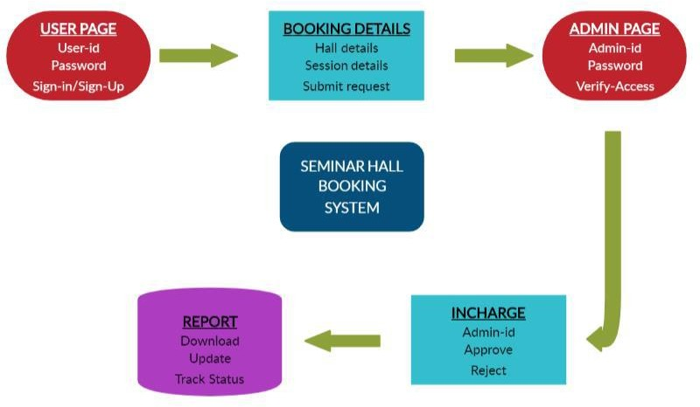

Fig 3.1 Block Diagram

## WORKING PRINCIPLE

* + 1. **HTML**

**Hypertext Mark-up Language** (**HTML**) is the standard markup language for creating web pages and web applications. With Cascading Style Sheets (CSS) and JavaScript, it forms a triad of cornerstone technologies for the World Wide Web. Web browsers receive HTML documents from a web server or from local storage and render the documents into multimedia web pages. HTML describes the structure of a web page semantically and originally included cues for the appearance of the document. HTML elements are the building blocks of HTML pages. With HTML constructs, images and other objects such as interactive forms may be embedded into the rendered page. HTML provides a means to create structured documents by denoting structural semantics for text such as headings, paragraphs, lists, links, quotes and other items. HTML elements are delineated by tags, written using angle brackets. Tags such as <img /> and <input /> directly introduce content into the page. Other tags such as <p> surround and provide information about document text and may include other tags as sub-elements. Browsers do not display the HTML tags, but use them to interpret the content of the page. HTML can embed programs written in a scripting language such as JavaScript, which affects the behavior and content of web pages.

## PHP

**PHP: Hypertext Pre-processor** (or simply **PHP**) is a general-purpose programming language originally designed for web development. It was originally created by Rasmus Leadoff in 1994; the PHP reference implementation is now produced by The PHP Group. PHP originally stood for Personal Home Page, but it now stands for the recursive initialism PHP: Hypertext Pre-processor. PHP code may be executed with a command line interface (CLI), embedded into HTML code, or it can be used in combination

with various web template systems, web content management systems, and web frameworks. PHP code is usually processed by a PHP interpreter implemented as a module in a web server or as a Common Gateway Interface (CGI) executable. The web server combines the results of the interpreted and executed PHP code, which may be any type of data, including images, with the generated web page. PHP can be used for many programming tasks outside of the web context, such as standalone graphical applications and robotic drone control.

## MYSQL

**MySQL** is an open source relational database management system (RDBMS). Its name is a combination of "My", the name of co-founder Michael Widenius's daughter, and "SQL", the abbreviation for Structured Query Language. MySQL is free and open-source software under the terms of the GNU General Public License, and is also available under a variety of proprietary licenses. MySQL was owned and sponsored by the Swedish company MySQL AB, which was bought by Sun Microsystems (now Oracle Corporation). In 2010, when Oracle acquired Sun, Widenius forked the open- source MySQL project to create MariaDB. MySQL is a component of the LAMP web application software stack (and others), which is an acronym for Linux, Apache, MySQL, Perl/PHP/Python. MySQL is used by many database- driven web applications, including Drupal, Joomla, phpBB, and WordPress. MySQL is also used by many popular websites, including Google (though not for searches), Facebook, Twitter, Flickr, and YouTube.

## MERITS AND DEMERITS

Some of the merits and demerits are

1. Cost-efficiency: Using this system reduces the cost of paper and in person surveys which are conducted also the administration cost is reduced.
2. Time saver: Hall Booking software saves a lot of time and effort. Performing all of these functions in one integrated web system saves you a extensive amount of time.
3. Convenience: It is very convenient for users to complete the bookings online. Participants can fill out forms when they needed hall for events.
4. Accessibility: Monitoring your bookings through an online system increases accessibility. The confirmation can be sent through the Gmail. The user have a variety of ways to access the system including mobile phones, laptops, tablets, computers, etc.
5. Reach & Scalability: One of the greatest advantages of using online system is the reach and scalability. You can book multiple halls at the same time.
6. Flexibility: Online system provide more flexibility in using the features. Both user and admin can get benefitted through this system.
7. More Accurate: Since the records are generated in the admin module and these records are accurate from the user request.

## APPLICATIONS

* + - Easy to book halls in the system.
    - Save time of user to book hall.
    - Web Application provides the user friendly screens for Data Entry.
    - Instant notifications on the successful booking of the hall.
    - Makes the processing of confirmation for Hall easy and fast.
    - It provides the interactive environment between the admin and users.
    - It makes the booking process more easy and efficient.
    - The booking data are stored in the database and can be accessed whenever required.
    - The approval process is fast and notified through email for the respective user.
    - The user can know the exact status of their request for booking a hall for an event.
    - This makes the user and admin comfortable throughout the process.
    - The rejection of the booking are also been notified with a valid reason to the user.
    - This project makes the ledger entry of the booking to an digital entry.
    - The data are stored and can be accessed for future verification or requirement.
    - The process provides security and privacy to the user and admin.

# RESULTS

Thus Hall Booking System is very useful for college to maintain the booking records of the users. The system not only maintains the booking details of the user, it also helps to book halls. The admin person may accept or reject the hall booking requested by the user. The confirmation or the cancellation can be sent through the Gmail that is given in the booking details. This system offers a reliable and easy to access. It can be used to book halls as well as check the availability at anytime and anywhere. Anyone can use this web application at any time as a user with the given password. The user can check the details of the page with the given help window and book the halls needed for them. It provides high security and a system that reduces the work and resources required in traditional process. The proposed system provides the new way of computing and displaying records with responsive and attractive user-interface. This system is user-friendly and flexible to access at any instant. The booking system maintains the data in the database that can be accessed by the admin whenever required. The data also can be downloaded and made available offline. The hall booking system makes the process quick as much as possible. The approval process are done by the admin. The admin also as their own login to approve the booking for the particular user the user is notified through email about the status of the booking. The project provides a more comfortable environment for both user and as well as the admin. The user can only book the available halls on the respective time. The user only can request the booking for available halls and the approval process are carried out by the admin of the entire booking system.

# CONCLUSION AND FUTURE SCOPE

As seen above, the common problem faced by the people these days is booking hall for the event. Due to lack of coordination or inefficient system, handling booking records becomes very difficult. With the help of the proposed system concerned faculties will have proper information about the person who is booking the halls. The hall booking system allows people to book the hall across multiple departments or other sources. The goal of this project is to book hall for the organization’s people and providing the response to user by sending the notifications through mail. This includes shared calendar management, unlimited users, remote device management etc. Booking is done on the bases of time or period. It can flexible for repeating booking. This project can be used in many organizations as a booking system because it saves time and makes the booking process easy and efficient. This makes the booking more secure and private. The project provides much better experience in the process of booking hall for events and it makes the user know about the availability of the hall. The approval process are carried out by the admin manually for as of now that can be automated on the future improvements of the project. The data and the availability of the hall are managed by the data stored in the database. The data can be accessed only by the admin of the entire booking system. The data can be made offline by downloading only by admin. The project makes the user and admin interact through emails may be in future a chatting system can be introduced in the booking system where it makes the user and admin more interactive and provides a more user friendly environment. The admin as all the control over the booking system.

## APPENDICES

* 1. **SCREENSHOTS**

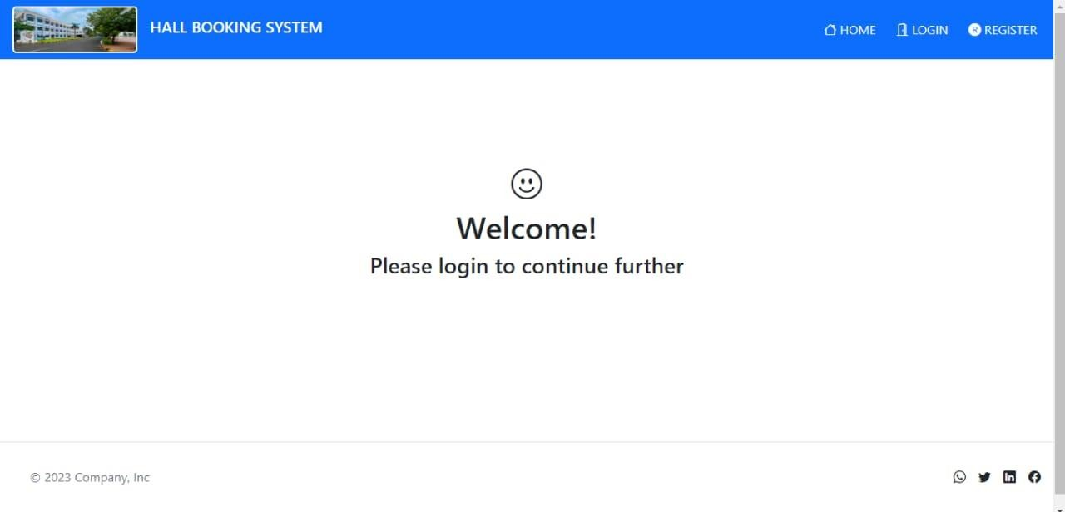

* + 1. Index Page

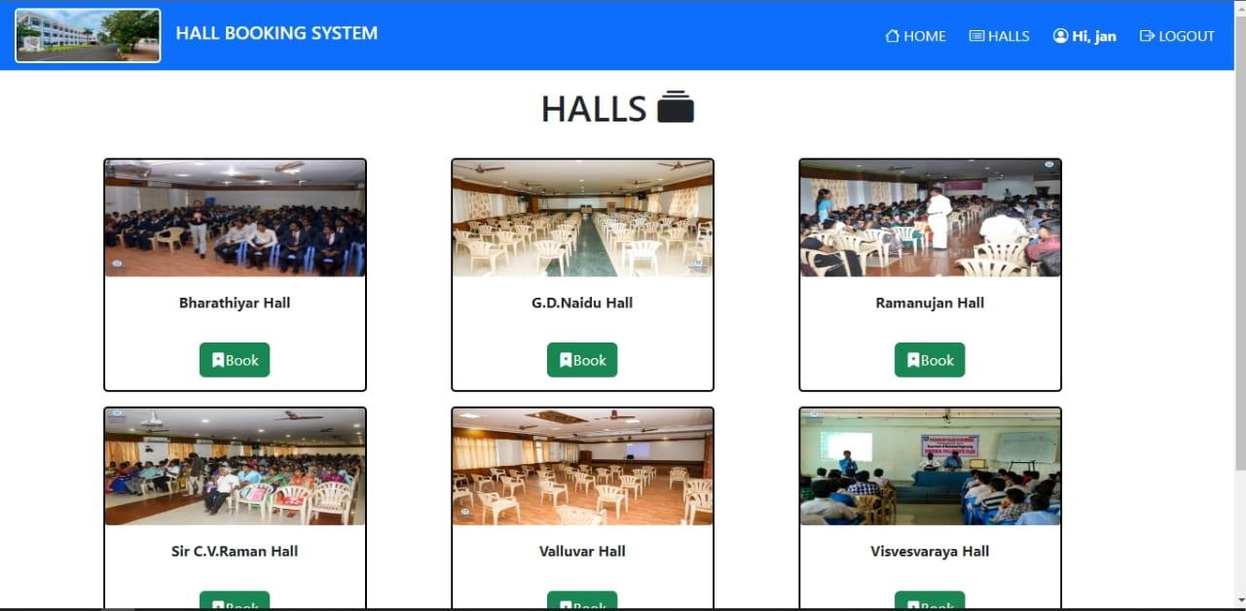

* + 1. Hall Selection

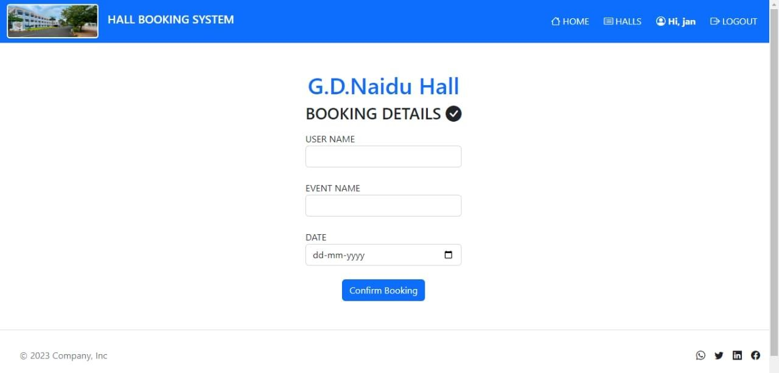

* + 1. Booking Details

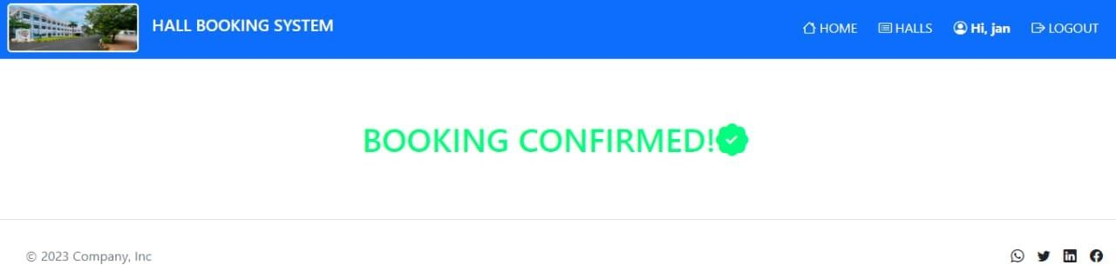

* + 1. Booking Confirmation

# REFERENCE

1. Mrs. OmprakashYadav, Ryan Fernandez, Rohit Tiwari, SheenamKaul.”Online Registratiion System Using OR Based Android Application System”.
2. Alison Batter: Sams Teach Yourself Microsoft SQL Server
3. 2005 express in 24 Shours, First edition
4. Tushar Dongare, Akshay Babar, Mahendra Nivangune. ”Android Application for Ticket Reservation with GPS as Ticket Validation”1995.
5. Niranjanamurthy M, Archikam Nagaraj, HimajaGattu, Puneeth K Shetty.”Research study on Importance of Usability of Testing/User experience”.
6. Baker, F.T.,"Chief Programmer Team Management of Production Programming, IBM System Journal, Spring”, 1972.
7. Alison Batter: Sams Teach Yourself Microsoft SQL Server 2005 express in 24 Shours, First edition.
8. Ron, Patton, “ Software Testing”, Second Edition, Pearson.
9. Damon Armstrong: Pro ASP.Net 2.0: Website programming, First edition.

 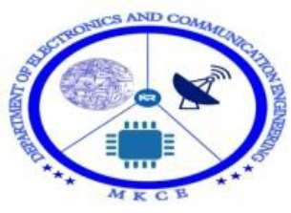 

*Proceedings of the*



DST-SERB



Sponsored



Second



International



Conference



on Signal



Processing



and



Communication



Systems

(ICSPCS 2023)

MARCH 07TH, 2023

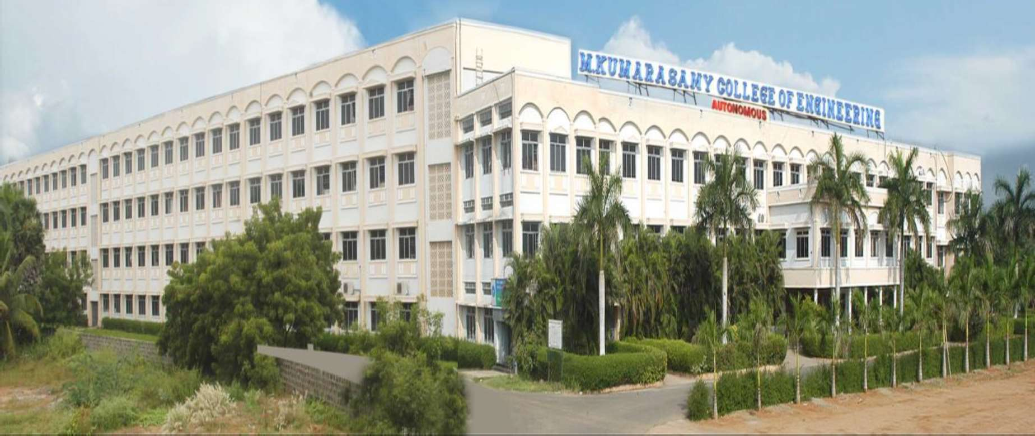

ORGANIZED BY,

# Research and Development Cell,

**Department of Electronics and Communication Engineering,**

M.KUMARASAMY COLLEGE OF ENGINEERING,

THALAVAPALAYAM, KARUR - 639113, TAMILNADU, INDIA

[www.mkce.ac.in](http://www.mkce.ac.in/)

  

©2023, M.Kumarasamy College of Engineering, Karur.

No part of the material protected by this copyright notice may be reproduced or utilized in any form or by any means, electronic or mechanical including photocopying, recording or by any information storage and retrieval system, without prior written permission from the copyright owners.

ISBN: 978-81-951431-8-4

Published by

M.Kumarasamy College of Engineering Karur 639113.

 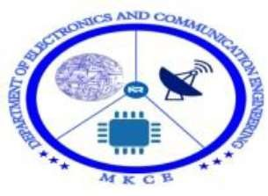 

|  |  |  |  |
| --- | --- | --- | --- |
| 126. | I121 | SMART SOLAR GRASS CUTTER | 67 |
| 127. | I122 | IOT BASED THREE PHASE POWER FAILURE MONITORING | 68 |
| 128. | I123 | DUAL MONOPOLE ANTENNA WITH EBG ARRAY FOR MUTUAL COUPLING REDUCTION | 69 |
| 129. | I124 | SUN TRACKING SOLAR PANEL USING ARDUINO | 69 |
| 130. | I125 | AUTOMATIC WHEEL CHAIR USING VOICE RECOGNITION | 70 |
| 131. | I126 | OBSTACLES AVOIDING USING ARDUINO WITH VOICE  CONTROLLER | 71 |
| 132. | I127 | RAIN DETECTION WITH AUTOMATIC CLOSE OF WINDOW USING RAIN SENSOR IN IOT | 71 |
| 133. | I128 | SMART SECURITY SYSTEMS FOR TRAIN USING IOT | 72 |
| 134. | I129 | CHATBOT USING ARTIFICIAL INTELLIGENCE | 73 |
| 135. | I130 | ACCIDENT PREVENTION SYSTEM | 73 |
| 136. | I131 | ALCOHOL DETECTION SYSTEM | 74 |
| 137. | I132 | RECTANGULAR MICROSTRIP PATCH ANTENNA | 75 |
| 138. | I133 | DESIGN OF LOW POWER 1-BIT FULL ADDER | 75 |
| 139. | I134 | HUMAN FOLLOWING ROBOT | 75 |
| 140. | I135 | WEBPAGE DEVELOPMENT ON HALL BOOKING SYSTEM | 76 |
| 141. | I136 | VOICE AUTOMATION CAR | 76 |
| 142. | I137 | HUMAN BODY POSTURE ANALYZER | 77 |
| 143. | I138 | DESIGN AND ANALYSIS OF SINGLE BAND MONOPOLE ANTENNA FOR WLAN APPLICATION | 77 |
| 144. | I139 | DESIGN OF TRI-BAND ANTENNA FOR WIMAX APPLICATION | 77 |
| 145. | I140 | CNC CONTROLLER | 78 |
| 146. | I141 | AUTOMATED PAPER VENDING MACHINE | 78 |
| 147. | I142 | VEHICLE STARTER USING ARDUINO UNO | 79 |
| 148. | I143 | SMALL SIZE RF ANTENNA FOR UAV APPLICATION | 79 |
| 149. | I144 | DESIGN AND IMPLEMENTATION OF MICROSTRIP FILTER USING FOR UWBAN APPLICATION USING CST | 79 |
| 150. | I145 | PCB DESIGN FOR SINGLE BOARD STEREO AMPLIFIER | 80 |
| 151. | I146 | TRAFFIC SYSTEM FOR EMERGENCY VECHICLES | 80 |
| 152. | I147 | DESIGN OF SMALL AUDIO BUG DEVICES | 81 |

DST-SERB Sponsored 2nd International Conference on Signal Processing and Communication Systems(ICSPCS 2023) ISBN: 978-81-951431-8-4

 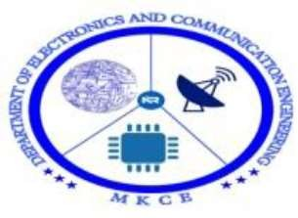 

Controller**.**

**PAPER ID: I135**

**WEBPAGE DEVELOPMENT ON HALL BOOKING SYSTEM**

*Dr.S.Palanivel Rajan Assistant Professor*

*K.Janani, UG Scholar*

*R.Janapriya UG Scholar*

*V.Jayarisha UG Scholar*

*C.Karnikashree UG Scholar*

*Abstract:*



*Department of Electronics and Communication Engineering M.Kumarasamy College of Engineering, Karur*



organisation or

university, a facility which is used to reserve Halls, cancellation of reservation and different types of route enquiries used on securing quick reservations. MYSQL is built for managing and computerizing the traditional database, Structured Systems Analysis and Design Methodology (SSADM), Data Analytics was adopted. In addition, Angular was used for the front-end of the software while the back end was designed using MySQL, Javascript. It is recommended that despite the present functionality of the designed software, an additional functionality such as the use of E-mail to send Hall Bookings and notifications to the User about status of a bookings and approval and highly authenticated process should be implemented into the system.

*Keywords:* MYSQL, Javascript, angular, SSADM

**PAPER ID: I136 VOICE AUTOMATION CAR**

*Dr.G.Shanmugavadivel Assistant Professor*

*Mathavan T UG Scholar*

*Kishor T UG Scholar*

*Manoj S UG Scholar*

*Kavin S UG Scholar*

*Department of Electronics and Communication Engineering M.Kumarasamy College of Engineering, Karur*

*Abstract:* Voice Controlled CAR is a mobile robot whose movement can be controlled by the commander by giving specific voice commands. The speech is received by a microphone and processed by the Bluetooth module (hc- Speech recognition is a technology where the system understands the words given through speech. 05). When a command for the robot is recognized, then Bluetooth module sends a command message to the Arduino. The Arduino analyses the message and takes appropriate actions. The RF transmitter of the Bluetooth can take either switch press or voice commands which are converted to encoded digital data for the advantage of adequate range (up to 100 meters) from the robot. The receiver decodes the data before feeding it to another microcontroller to drive DC motors via motor driver IC for necessary work. This technology has an advantage over long communication range as compared to RF technology. Further the project can be developed using IoT technology where a user can control the robot from any corner of the world. The goal of this project is to introduce hearing AI sensor and also the speech recognition to the mobile robot such that it is capable to interact with human through Spoken Natural Language (NL).

*Keywords:* Speech Recognition, Microcontroller, Arduino, Bluetooth, Android.

DST-SERB Sponsored 2nd International Conference on Signal Processing and Communication Systems(ICSPCS 2023) ISBN: 978-81-951431-8-4

76